

Animoto makes it possible to quickly create a video using still images, music, video clips, and text. If you can make a slideshow presentation, you can make a video using Animoto. Animoto provides a large library of free music and free images that you can use in your videos. Animoto also provides a nice selection of video player themes for different occasions. For example, you can make a video
birthday card using Animoto. Animoto videos are easily embedded into blogs, wikis, and websites. Animoto's free service limits you to 30 second videos. You can create longer videos for free if you apply for an education account. Education accounts also allow to manage student accounts.

Login and select create new video
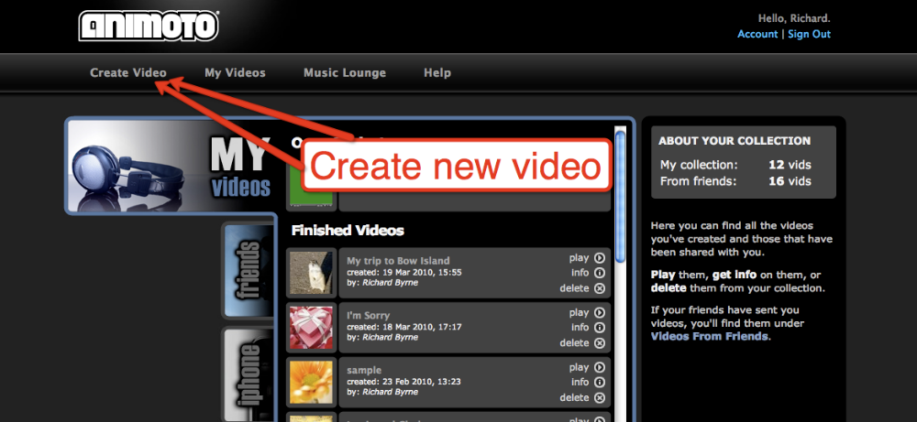

Step 2: Select duration of video. If you do not have an education
account you will be limited to 30 seconds.
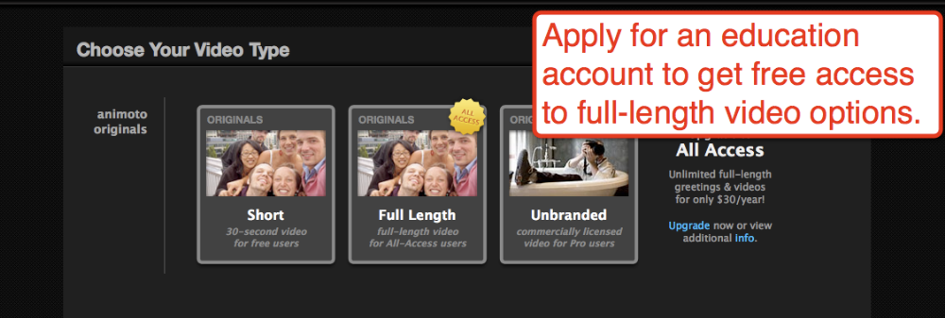

Step 3: Upload images or select images from Animoto’s collection.
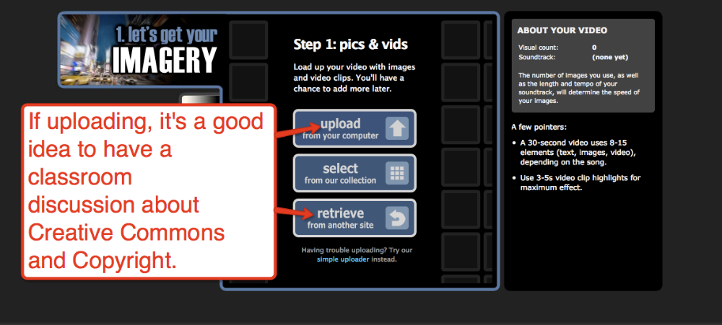

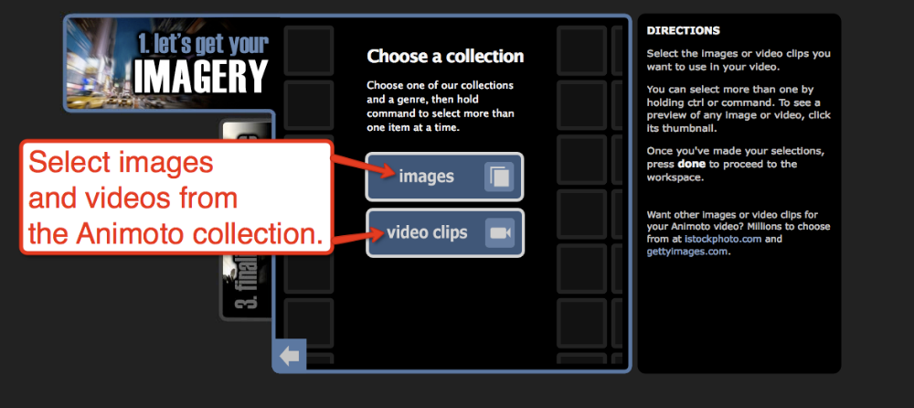
Step 3a: Selecting multiple images from Animoto’s collection.
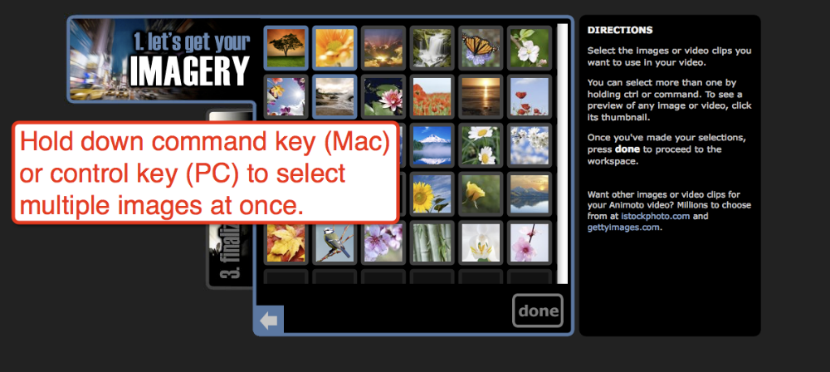

Step 4: Arrange the sequence of your images. Add text slides.
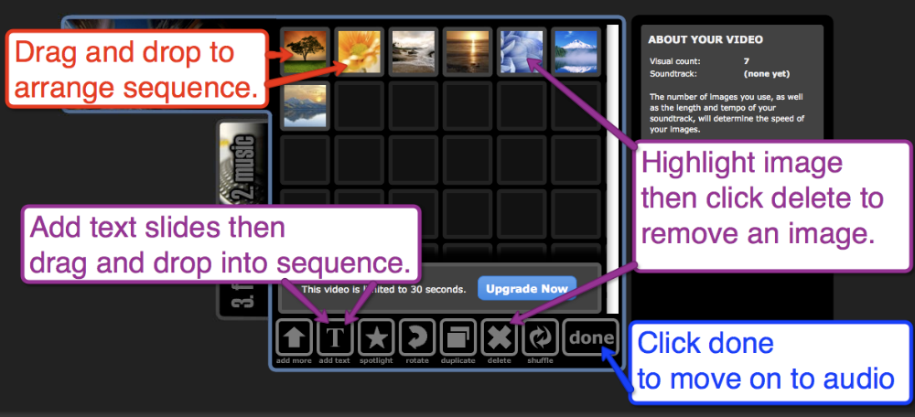

Step 5: Select music from Animoto’s collection or upload your own.
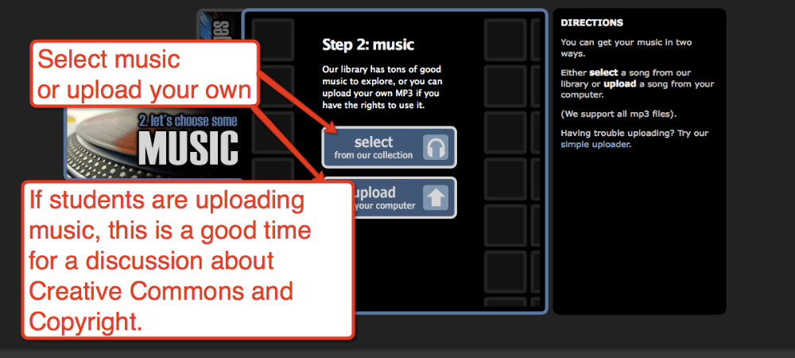
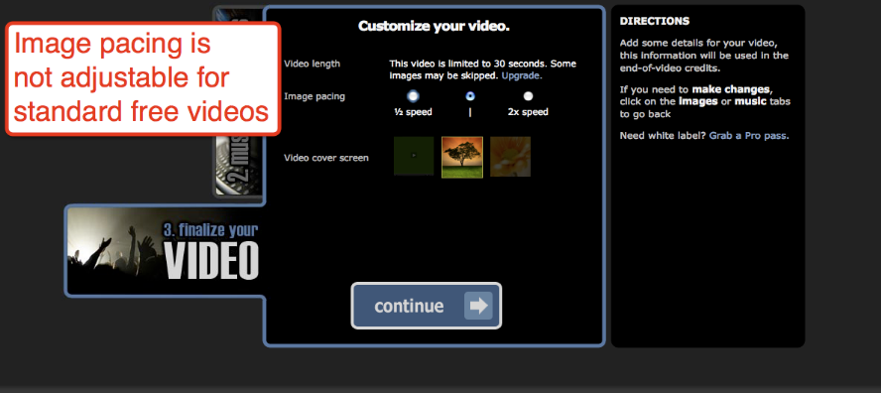
Step 6: Select image pacing.

Step 7: Enter video title, description, and producer’s name.
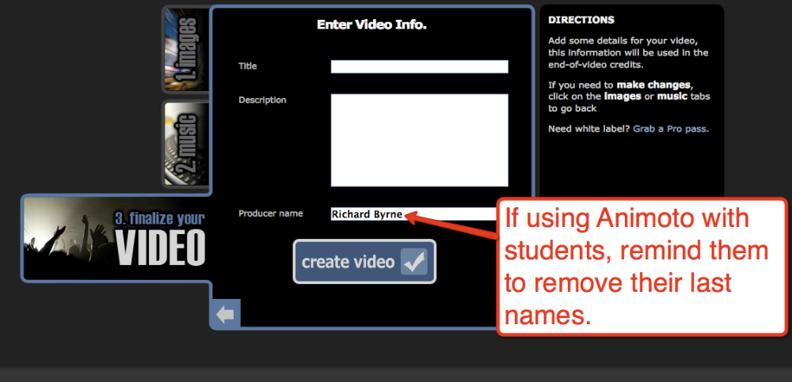
Step 8: After video is created, select how you want to share it. Select embed to place it in a blog or wiki.
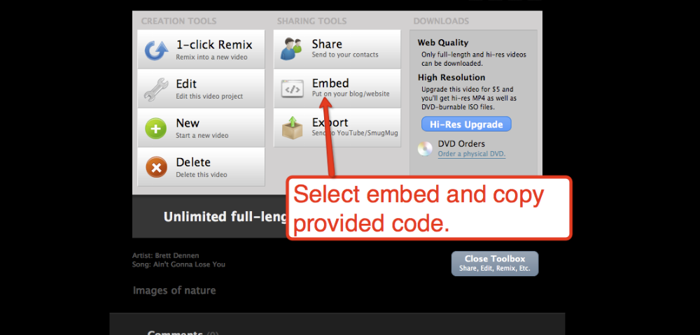

Copy embed code provided by Animoto
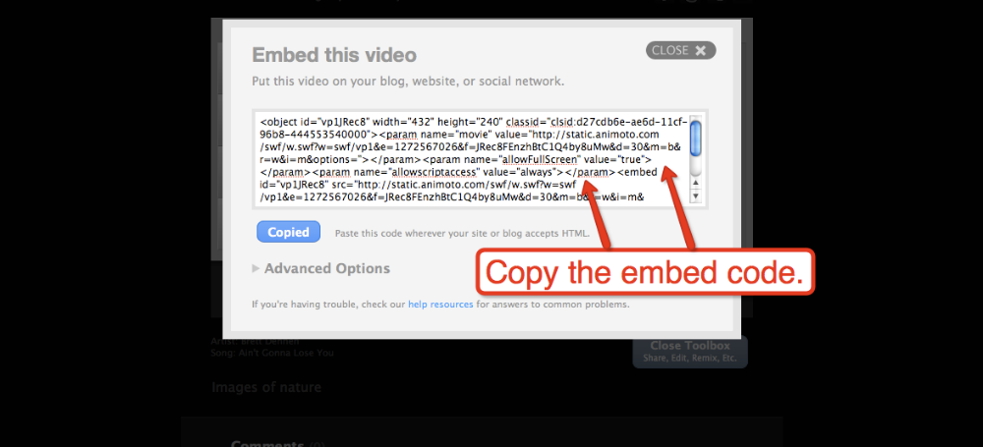

In Blogger, simply paste embed code into your post html editor then post.
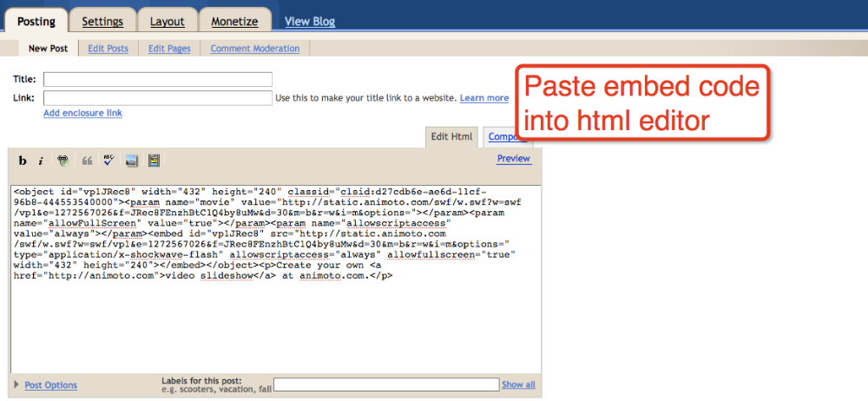
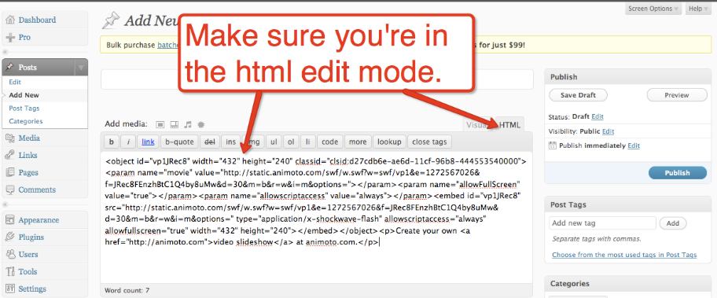
In Edublogs, create a new post using the HTML mode. Video might not display correctly if the post is created in the “visual” mode. Past embed code into HTML editor.



