Youtube Plugin 2003
Insert the YouTube Video into PowerPoint 2003
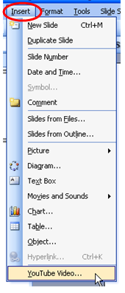
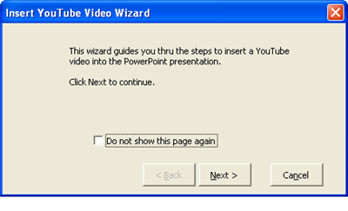
Get the YouTube URL
- Using your web browser, visit the YouTube video you wish to add to your PowerPoint presentation and copy the URL (the address link).
- Paste the link into the YouTube Video Wizard dialog box where indicated.
- Click Next

Step 2 - Select the Options for the YouTube Video to Play in PowerPoint
Step 3 - Set the YouTube Video Size on Your PowerPoint Slide
YouTube Video Size is Important
- By default, the YouTube video size is set to 50% of the PowerPoint slide. This is probably the best size to use. You can set any size you like for the video to play, but be aware that choosing a larger size will show some distortion in the video.
- Secondly, you may choose where to place the YouTube video on your slide.
When you click on the Finish button the YouTube video will be imported into your PowerPoint presentation.

