YouTube Add-in for PowerPoint 2007

Download the YouTube Video Add-in for PowerPoint 2007.
Extract the Add-in from the Zipped File
- Double click on the newly saved zipped file.
- Right click on the file named YouTubeVideo2k7.ppam.
- Click on Copy
- Navigate to the location on your computer where you wish to save the add-in file.
- Paste the YouTubeVideo2k7.ppam file to this new location.
Install YouTube Videos Add-in for PowerPoint 2007
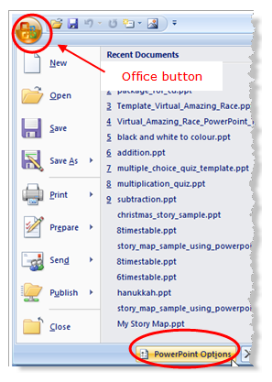

Now that you have downloaded and saved the YouTube Videos add-in on your computer, it is time to install it to your PowerPoint 2007 program. This is a one time event.
- Click on the Office button.
- Click on the PowerPoint Options button at the bottom of the expanded menu.
Access the PowerPoint 2007 Add-ins in the PowerPoint Options
PowerPoint 2007 Options
- In the PowerPoint Options dialog box, Click on Add-ins in the left list.
- At the bottom of the PowerPoint Options dialog box, click the drop down arrow in the Manage area.
- Select PowerPoint Add-ins from the list of options.
Add-ins Dialog Box to Install YouTube Videos
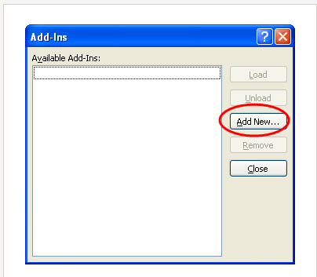

Add-ins Dialog Box
- In the Add-ins dialog box, click on the Add New... button.
- Locate the YouTube Videos add-in file named YouTubeVideo2k7.ppam that you saved earlier.
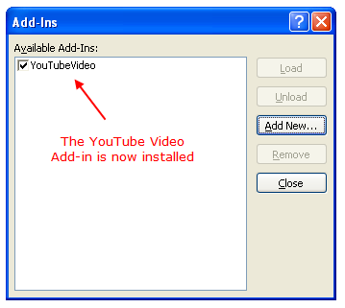
- Click OK.

YouTube Videos Button on the Insert Tab of the Ribbon

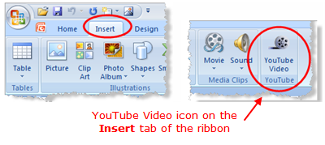
Access the YouTube Add-in
Now that you have installed the YouTube Videos add-in, you can now add YouTube videos to your PowerPoint 2007 presentations. The YouTube add-in is a new button located on the Insert tab of the ribbon.

